CXP TEPR Proposal

SWD: 2006/06/12 Version 0.3

[Note: This is just a revised version of the TEPR spec – that was Version 0.2. The goal for this document is to have:
- Something we can send to the Jaroka folks
- Something we can agree on for what the secondary registry does.

I’ve added Sex to the dictionary list. Otherwise – most of the change has been to the first few pages which are more questions than answers. There’s a lot of TEPR stuff still in here – but it would be easier to edit out once we’ve agreed on the general direction.

]

Introduction 2
Unsolved issues 2
Nomenclature 2
Security 2
Generality of the API 3
Exposing internal MedCommons state 5
Other needed changes to CXP 5
Requirements 6
Overview 7
Protocol Implementation 9
Metadata Dictionary 9
Record Locator Service 9
CXP Service 10
CXP PUT 12
CXP GET 13
Record Locator Service Query 14
Add CCR mechanism for TEPR Record Locator Service 15
QUERY mechanism for TEPR Record Locator Service 16
Example: how to retrieve a CCR via HTTP 17
Appendix A: What MedCommons plans to provide for TEPR 18
Appendix B: XPath expressions for extracting data for Record Locator Service metadata 18
Appendix C: URLs for TEPR Demo 19
CXP 19
TEPR Record Locator Service 19

Introduction
This document describes the CXP interface to a Record Locator Service (RLS).

[We need an overview section here. I’m deferring writing that until the issues below are settled. It’s certainly possible that we don’t settle some of the issues but we should be clear what things we’re leaving open to keep ourselves flexible. The bullets below get replaced in an iteration or two of this document by sections being inserted in the right places elsewhere in the document.]

Unsolved issues

Nomenclature
On one hand this doesn’t really matter – we should just choose some words and stick with them. On the other – we confuse others and ourselves by the words we use.
  - Secondary Registry == Record Locator Service
I have a strong preference for Record Locator Service because that describes better what we are doing and Forslund complained that Secondary Registry means something else in another context. But – RLS might not be the right word – it depends on what the scope is of the Jaroka project. To the degree that it’s a workflow system and we add variables that are more work-flowish – it really goes beyond what a RLS is.
  - Primary Registry == PHR Service == CXP Service
I don’t like terms “Primary Registry” or “PHR Service”.
Primary Registry doesn’t mean anything (see discussion above).
PHR service needs to be defined. What are the services that are provided? It’s a perfectly good term for something that MedCommons may want to offer – but it’s too grandiose for the protocol here. I suggest “CXP Service” because it’s something limited to the scope of CXP and we can decide what it means as we go along. We really want a nice concept here – not just API names or a set of things like “tracking numbers, pins,…”.

Security
  - There’s the whole trusted host thing. We probably should only be doing TLS; perhaps the HMAC thing should be done too.
  - Consent right now is an opt-in mechanism for the CXP SOAP interface.
  - What information can be shared? This is dealt with a little below as mechanism – but there are two big issues:
    - Who decides what is shared? Is it the sending client or the Primary Registry? I’ll assume the sending client below – but it’s problematic because the “Primary Registry” generates some of the data (like tracking number, GUID, &etc..).
    - What is shared? Do we set any limits?

Generality of the API
There is a choice here that I think is useful to make at this stage: Is the interface between a CXP server and a RLS or between a CXP server and a more general system too (like a workflow system). There is a closely related issue about what the scope is of CXP – I know this is a separate issue but I think we need to deal with them together.

Right now Adrian, Lewis, Bill, and I have had separate conversations about adding web services to CXP – specifically Lewis wants to add on services like
- “Anonymize CCR”
- “Merge CCR”,
- “Give me recommended Medicare Part D plans given my medical history”
- “Give me clinical guidelines for my health status” (Jim May’s CINA system)

So far much of the discussion has been focused on are the calls synchronous or asynchronous - Bill and Adrian are in the asych camp (for different reasons I think), Lewis thinks that they are 90% synchronous, and I’m straddling the fence (I just want a protocol that could be used in either mode so we don’t have too many protocols to deal with). We’ll put that discussion aside for the moment because I think on the MedCommons side if we’re going to do both we’d do the asynch one first anyway. Another issue is what the service is called. Adrian is very firm that it has to be CXP and by that he means “PUT”. I think this is wrong – we need a different verb here for a number of reasons:
- PUT currently is matched with GET and DELETE for the type of thing that it does – it deals with a single document. But a “Merge” would deal with more than one. So – the structure of the parameters for PUT doesn’t match this case.
- PUT currently returns a parameter block with the GUID and the tracking number/pin. But for a service like “Anonymize” – what would it return? Lewis wants it (in the synch chase) to return a single CCR. For the asynch case – what is it? We probably return the tracking number/pin/guid for the input document – but I guess we have a second transaction number for getting the anonymized output. These could be generated by the secondary registry or by some internal mapping we made of the secondary registry numbers internally so we could present a unified interface.
- We’ll need a new method STATUS to check on asynchronous transactions. I’m guessing that it would take these ‘secondary registry tracking numbers’ as input.
- For operations like ‘Anonymize’ – it may be that the last thing that the user wants is for the data to be stored on MedCommons. They might want something that is much more like a standard web service that they pass the data to it and get a reply - and no copy of the original is kept.

But – if we’re going to put everything into PUT – what we’re really doing (and this is why I’m bringing this up in this memo) is making the registry parameter block data into a declarative programming construct. I think this is what Adrian is pushing for – it’s object-oriented in the sense of SmallTalk where objects are sent messages and from the message it figures out what to do. This in turn means that the parameters in the registry parameter block have to be determined more by the client than by the CXP Service – it’s too general a model for us to handle in our server so passing things through is the right approach.

What’s the practical implication? One is that the current API mechanism won’t expand gracefully – we currently send the same data to each secondary registry. If it’s more of a programming language construct this doesn’t’ work.

Other issues in the Metadata:
- The current design just gets data from the CCR unless it’s already been specified in the registry parameter block. For example: if the Purpose hasn’t been defined by the client we extract it from the CCR. This is a weak model and I think it needs to be tightened up a little bit: the reason that it might not have been specified is that the client didn’t want the data to be sent to the secondary registry. Here’s a proposal:
  - If data is specified in the registry parameter block – then send this data.
  - If the data is specifed in the registry parameter block as “*” – then grab the value from the source data or a ‘earlier’ registry parameter block entry.
    - From the source data – for CCR we define some XPath rules for what data is extracted.
    - From the earlier registry parameter blocks – for things like “ConfirmationCode”, RegistrySecret, or “GUID” that are generated by other services and are not known to the client – they are generated by a server process. Note that RegistrySecret could have been defined in another registry parameter block *or* might be generated by the server.
  - If the data is blank – don’t send anything.
- There may need to be a filter for certain types of metadata. For example – we might not want the PatientFamilyName to be sent out to a particular secondary registry. We may not be able to prevent the client from sending this data – but we can prevent our implementation from extracting it or even passing a field called “PatientFamilyName”. If the client goes around this with a “PatientFamilyNameX” we’ll just pass it through – but it’s clear that they are abusing the system.

Exposing internal MedCommons state
This one is much more minor than it sounds. Right now there are two ways that the secondary registry mechanism is invoked:
- Via CXP PUT
- Via viewer notify.

We just need to document these two cases. This memo is currently very CXP focused.

Other needed changes to CXP
As far as I know – the only other needed change is:
- Add mime type (or content type) to PUT.

We may add non-CCR data in the future.

Requirements

- Security/Encryption.
  - Security for CXP Server-RLS interactions:
TLS for all communications between CXP server and the HMAC mechanism for all web service calls between the two entities (note – this is the opposite direction of the central->gateway redirection we’ve already done).
  - Security for CXP Client-CXP server interactions (TBD). [it may be the case that the Secondary Registry needs to know the client’s identity]
  - Logging. What is logged (if anything) when data is sent out of the system via the web service calls.
- The system must be compatible with multiple CXP servers from different vendors.
- We want to support registries only as a client opt-in on the protocol level. This means that a client can save and retrieve data via CXP but *not* have the data indexed in a registry used for general queries. We think that this is a pretty fundamental issue for patient privacy and is a necessary step to building a functioning RHIO. Note for TEPR we dropped this because otherwise HealthFrame would have been dropped.
- Any client should be able to get data from any CXP server via any ‘Secondary Registry’ if security requirements are met. [What exactly this means needs to be worked out – but the gist is that while ‘Secondary Registries’ may have proprietary APIs that when the client is redirected to the CXP server to get the data that there shouldn’t be anything proprietary there. Otherwise the value of CXP is much less]
- Notifications are sent to the RLS on the following transactions
  - PUT – when data is entered via CXP for a registry the correct data is send to it]
  - GET – If we’ve gotten a redirect from a secondary registry for a GET – do we send them an events?
  - DELETE – If a record is deleted – do we keep track of in which RLS the data is referred to and send a DELETE message out to them?
- There is no requirement #6 ☺

Overview
This diagram shows the main components of the CXP servers, Record Locator Service, and client software together with the protocols that connect them. If it’s wrong let’s fix it.
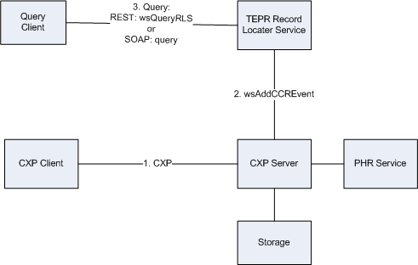

Figure 1: Relationship between network components

Some definitions:
- The Storage system contains data.
- The PHR service has some identifiers for the data (information on where it is stored, encryption keys, tracking numbers, &etc.). At the level of this diagram – the PHR service manages some metadata for the storage system.
- The TEPR Record Locator Service contains metadata useful for queries. So – a patient’s name, DOB, identifiers.. all belong here. Queries are performed against these registries is independent of the CXP servers.
- The CXP Server is a server that implements the CXP WSDL or the CXP REST API; for it to work in the TEPR demo it needs to invoke the wsAddCCREvent web service which pushes data to the TEPR Record Locator Service.
- The CXP Client is an application that has client CXP code. It does the PUT and GET.
- The ‘Query client’ queries the TEPR Record Locator Service. It may or may not be in the same application as the CXP client. Two implementation alternatives are:
  - They are separate applications; the query client is running in a web browser and the registry secret/confirmation code is copied (via cut&paste) into the CXP client.
  - The are the same application – the query client displays some values (via SOAP or REST), lets the user select one record, then uses CXP to extract the data to their local system.

In MedCommons there is a distinction between storage and PHR service; other vendors may not make a distinction between these services. CXP hides these details. For TEPR we propose that there be a single TEPR Record Locator Service and that all CXP Server vendors invoke the wsAddCCREvent service.

The protocols:
- CXP. PUT places the document on the repository; GET returns them. Both SOAP and REST APIs are supported.
- Communication between the CXP server and the RLS is via the wsAddCCREvent REST service.
- Separate SOAP/REST query interface to the RLS so that CCR references can be retrieved from the RLS. A web page interface is also required because some vendors may want to look at the values and cut/paste them into a CXP client if there isn’t time for integration.

Protocol Implementation

Metadata Dictionary

Record Locator Service

This table defines all of the metadata elements in the TEPR Record Locator Service. The SOAP registry parameter blocks, the REST parameters, and the XML returned from the REST calls all use these names.

Name | Type | Definition
PatientGivenName | Varchar(64) | This is the patient’s given name as defined by the CCR.  When this field is used in a query the wildcard % can be used for partial matches.
PatientFamilyName | Varchar(64) | This is the patient’s family name as defined by the CCR.  When this field is used in a query the wildcard % can be used for partial matches.
PatientIdentifier | Varchar(64) | This is the patient’s identifier for TEPR. Since we don’t have a registration service at TEPR there is no standard way to provide this identifier. MedCommons uses the “CommonsId” if no other data is supplied but other vendors can use other identifiers.
Guid | Varchar(64) | A global identifier for the CCR. In the MedCommons system this is the SHA-1 hash of the contents of the document.
Purpose | Varchar(64) | The default value is the CCR’s Purpose description field.
SenderProviderId | Varchar(64) | The identifier of the sender of the CCR. May be left blank. A dictionary of these should be worked out before TEPR. More details in the issues section below.
ReceiverProviderId | Varchar(64) | The identifier of the receiver of the CCR. May be left blank. A dictionary of these should be worked out before TEPR. More details in the issues section below.
DOB | Varchar(64) | Patient’s date of birth. May be left blank. The format of this is pretty much unconstrained for the TEPR demo.
CXPServerURL | Varchar(255) | URL of the CXP server
CXPServerVendor | Varchar(255) | Name of the CXP server vendor
ViewerURL | Varchar(255) | Link to a viewer for the CCR.
Comment | Varchar(255) | This is used as a separate
CreationDateTime | Bigint(20) | Timestamp of when this entry was made in the table.
ConfirmationCode | Integer (12 digits) | This is the Tracking number used by the FireFox and CXP clients. Value set by the CXP service.
RegistrySecret | Integer (5 digits) | This is the PIN value used by the FireFox and CXP clients. Value set by the CXP service.
Sex | Varchar(8) | Sex of the patient: {Male, Female, Unknown}
limit | Integer | For RLS queries – this specifies the maximum numbers of rows that are to be returned. This is a required field for queries.

CXP Service
Name | Type | Definition
CommonsId | Int | Patient’s identifier in the CXP service. For TEPR – probably should be identical to the PatientIdentifier.  If no CommonsId is specified – a randomly generated one is used instead.
ConfirmationCode | Integer (12 digits) | A ‘tracking number’ for the CCR. Together with the confirmation code this provides access to a document. Typically the tracking number is sent to another party to access the document.  The ConfirmationCode is generated by the CXP service.
RegistrySecret | Integer (5 digits) | This value can be set by the user; if blank it a randomly generated value is created by the CXP service. This value is forwarded to the RLS.
Guid | Varchar(64) | The document identifier for the CCR. This value is calculated by the CXP Service.

CXP PUT

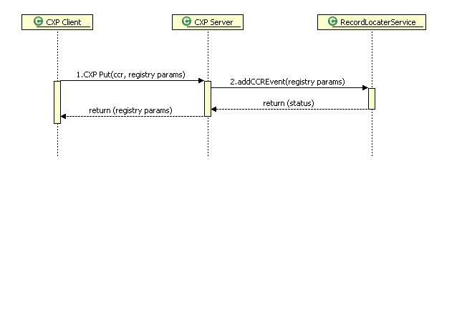
Figure 2: CXP PUT
On one level – this is a very simple transaction. If the CXP client includes the correct entries in the ‘registry parameter block’ for the TEPR server then the specified data is transmitted to the RLS.

For TEPR the explanation is slightly more complex.
- For the CXP REST API the parameter RegistryEnabled must be set to the value “TEPR” for the addCCREvent() service to be invoked.
- For the CXP SOAP API – while a second registry parameter block for “TEPR” can be set with registryName=”TEPR” and these values will be passed to the RLS – the current implementation does not provide an opt-out mechanism. ALL CXP SOAP transactions invoke the addCCREvent() service.
The reason for this is that there are products which implement the CXP SOAP API which are shipping products and they don’t have the TEPR metadata registry calls. So, for TEPR, we are publishing all of this data to the RLS. How we’re going to handle this in the future needs to be discussed further.

CXP GET
CXP GET is used to retrieve a CCR.

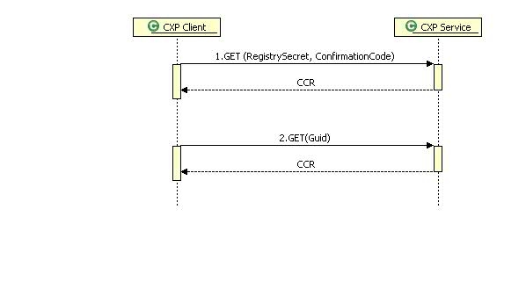
Figure 3: CXP GET
There are two sets of parameters that can be used for retrieval:
- {RegistrySecret, ConfirmationCode}
- Guid

There are two different protocol implementations: CXP SOAP and CXP REST. GET returns the bytes of the CCR. In the SOAP implementation this is in the response’s content field; in the REST implementation it is just returned as a stream of bytes.

Record Locator Service Query

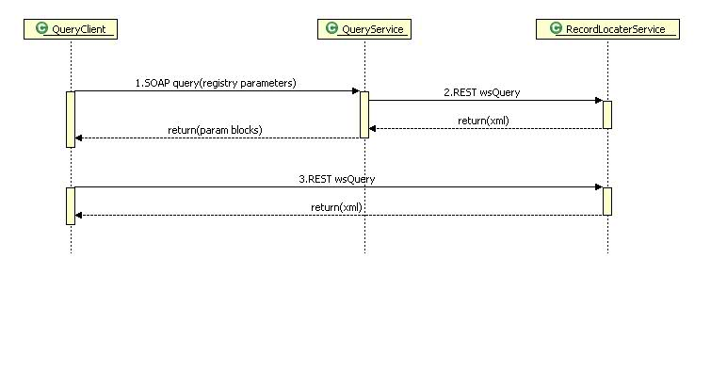
Figure 4: Record Locator Service Query

The RLS diagram above shows the difference between the two query implementations at the TEPR. A QueryClient can use the SOAP or REST query service. The results are identical except for the format of the messages.

A client that needs to do a query needs to invoke only one of these calls.

Alternatively – a client could simply launch the query web page (see the URLs in Appendix C) and cut and paste values from this into their CXP client software.

Add CCR mechanism for TEPR Record Locator Service
There is currently only a single mechanism for adding data to the TEPR Record Locator Service. This section is probably of interest only to people who are implementing a CXP Server.

The service is
https://secure.private.medcommons.net/rls/wsAddCCREvent.php

For example:
https://secure.private.medcommons.net/rls/wsAddCCREvent.php?PatientGivenName=Doe&PatientFamilyName=John&PatientIdentifier=1234567890123456&PatientIdentifierSource=self&SenderProviderId=Vendor1&ReceiverProviderId=Vendor2&DOB=2001-01-01&ConfirmationCode=999999999999&RegistrySecret=99999&Guid=fb8eb261260aaa9aeb7864d9d1fad0d9fc98b05e&Purpose=&Comment=Test
Would create a new RLS entry for a CCR belonging to John Doe.

The parameter names follow the dictionary specified in a table earlier in this document.

There is currently no DELETE mechanism for the TEPR Record Locator Service.

QUERY mechanism for TEPR Record Locator Service
We believe that most vendors will want to use the web page query – see Appendix C “QUERY working documentation” for more details. This section is for vendors who are implementing a programmatic interface.

There are two separate query mechanisms:
- REST
- SOAP

Both use the same data – it’s just two paths to getting the data. The third path for getting to the data is on a web page – see the “QUERY working documentation” URL in Appendix C.

For example:
https://secure.private.medcommons.net/rls/wsQueryRLS.php?limit=4&PatientGivenName=B%

will return the REST XML for all patients whose PatientGivenName starts with the letter B. Note that the parameter limit is currently a required field but can be as large as you want it to be.
Performing the same query via the SOAP API is a few more lines of code:
CXPTEPR.QUERY.RegistryParameters inputParameter =
new CXPTEPR.QUERY.RegistryParameters();

inputParameter.registryName = "TEPR";
inputParameter.registryId =
“https://secure.private.medcommons.net/rls/";

CXPTEPR.QUERY.Parameter []parameterList = new CXPTEPR.QUERY.Parameter[1];
parameterList[0] = new CXPTEPR.QUERY.Parameter();
parameterList[0].name = "PatientGivenName";
parameterList[0].value = “B%”;

CXPTEPR.QUERY.QueryResponse [] responses =
queryServer.query(inputParameter);

Basically – the same parameters used in the PUT and GET can be used in a QUERY. The difference between QUERY and GET is that QUERY just returns the metadata, GET returns the object.

Example: how to retrieve a CCR via HTTP

- Query the RLS for a given patient. Either use the web page or the SOAP query client – or enter this URL for the rest results for a patient with last name “Doy%”:
https://secure.private.medcommons.net/rls/wsQueryRLS.php?limit=4&PatientFamilyName=Doy%

- In the REST results the following results are returned:
<Guid>fb8eb261260aaa9aeb7864d9d1fad0d9fc98b05e</Guid>
<ConfirmationCode>164294228307</ConfirmationCode>
<RegistrySecret>12345</RegistrySecret>
In the web page these are just columns in HTML that you can cut & paste.

- Now launch the page
https://cxp.medcommons.net/router/documentation/TestRestCXP.html
and enter fb8eb261260aaa9aeb7864d9d1fad0d9fc98b05e in the GUID field.
The CCR should now appear in your web browser.

- Alternatively – the URL
https://cxp.medcommons.net/router/CxpRestServlet?Command=GET&Guid=fb8eb261260aaa9aeb7864d9d1fad0d9fc98b05e
will return the CCR.

- And – if you wanted to use the ConfirmationCode/RegisrySecret access these could be entered in the TestRestCXP.html form, or you could enter:
https://cxp.medcommons.net/router/CxpRestServlet?Command=GET&ConfirmationCode=164294228307&RegistrySecret=12345

- And – in the FireFox client you could enter the Tracking Number 164294228307 and PIN 12345.

- Lastly – the RecordsForLiving application (which uses the CXP SOAP API) can retrieve the data via the Tracking Number and PIN mentioned above.

Appendix A: What MedCommons plans to provide for TEPR

- A CXP server
- The TEPR Record Locator Service that will be able to be queried by multiple vendors via REST or SOAP; a web page viewer is also available so that the values can be cut and pasted into a CXP client that does not implement the new QUERY service. .
- A simple CXP client application that can be used to PUT and GET CCRs for vendors that have not yet implemented CXP in their product. This client runs in Firefox.
- A simple CXP REST client web form for PUT and GET: https://cxp.medcommons.net/router/documentation/TestRestCXP.html
- Also, the C# application whose source is part of the CXP distro can be used as well. A version of the C# application which supports the SOAP QUERY API will be posted soon – if you need the working version please email me and I’ll send it to you ASAP.

Appendix B: XPath expressions for extracting data for Record Locator Service metadata

Purpose | <xsl:value-of select="/a:ContinuityOfCareRecord/a:Purpose/a:Description"/>
PatientGivenName | <xsl:value-of select="a:ContinuityOfCareRecord/a:Actors/a:Actor[a:ActorObjectID=/a:ContinuityOfCareRecord/a:Patient/a:ActorID]/a:Person/a:Name/a:CurrentName/a:Given"/>
PatientFamilyName | <xsl:value-of select="a:ContinuityOfCareRecord/a:Actors/a:Actor[a:ActorObjectID=/a:ContinuityOfCareRecord/a:Patient/a:ActorID]/a:Person/a:Name/a:CurrentName/a:Family"/>
DOB | <xsl:call-template name="dateTime">  <xsl:with-param name="dt" select="a:ContinuityOfCareRecord/a:Actors/a:Actor[a:ActorObjectID=/a:ContinuityOfCareRecord/a:Patient/a:ActorID]/a:Person/a:DateOfBirth"/>  </xsl:call-template>
TBD | Need to finish table
Note that the template “dateTime” is derived from Stephen Waldren’s templates/datetime.xsl. The only difference is that the HTML markup tags have been removed from the output.

Appendix C: URLs for TEPR Demo
This document is certainly imperfect – but one way to learn how this works for TEPR is to use either the FireFox client or the CXP REST working documentation link below and invoke the PUT and GET messages while looking at the QUERY working documentation link in another web browser window to see how records are added when you do a PUT or that values from the query output can be used in a GET.

CXP
CXP SOAP WSDL | https://cxp.medcommons.net/router/services/CXP?wsdl
CXP SOAP endpoint | https://cxp.medcommons.net/router/services/CXP
CXP REST working documentation | https://cxp.medcommons.net/router/documentation/TestRestCXP.html
CXP REST URL | https://cxp.medcommons.net/router/CxpRestServlet

TEPR Record Locator Service
QUERY working documentation | https://secure.private.medcommons.net/rls/
QUERY REST URL | https://secure.private.medcommons.net/rls/wsQueryRLS.php
QUERY SOAP WSDL | https://cxp.medcommons.net/router/services/QUERY?wsdl
QUERY SOAP endpoint | https://cxp.medcommons.net/router/services/QUERY

We shouldn’t take Forslund’s complaint as gospel – but I did do some Googling around and while there is no one meaning it usually seems to suggest a backup of a ‘primary registry’ (so it’s just a copy) or that they don’t overlap with the primary one (e.g., you search first at the primary one; if you don’t find something you go to the secondary one).
For non CCR data we’ll need other rules.
The ConfirmationCode is the API and internal registry name for the ‘TrackingNumber’ used at the UI level; the RegistrySecret is the API and internal registry name for the ‘PIN’ used at the UI level. The distinction is that we anticipate that there are multiple different kinds of ConfirmationCodes/RegistrySecrets that aren’t viewed as users as TrackingNumbers/PINS. This needs to be more clearly defined as CXP goes forward.

